2016

1.Assume that the United States economy is currently in a short-run equilibrium with the actual unemployment rate above the natural rate of unemployment.
(c)If the Federal Reserve Bank wants to lower unemployment, what expansionary open-market operation should it use?
(d)How will the open-market operation you identified in part (c) affect each of the following?
(i)Federal funds rate. Explain.
(ii)Real interest rate in the short run.
(e)Given your answer in part (d)(ii), what is the effect on real gross domestic product (GDP) in the short run? Explain.

2.The following is the balance sheet of First Superior Bank.

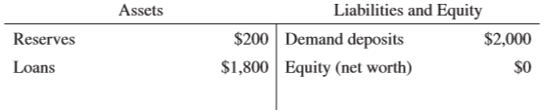

Assume that the required reserve ratio is 10 percent.
(a)What is the dollar value of new loans that First Superior Bank can make? Explain.
(b)Mr. Smith deposits $100 of cash in a demand deposit account in First Superior Bank. Calculate the maximum amount of new loans that First Superior Bank can now make.
(c)As a result of Mr. Smith’s $100 cash deposit, calculate the maximum change over time in each of the following in the banking system.
(i)Loans
(ii)Demand deposits
(d)As a result of Mr. Smith’s $100 cash deposit, calculate the maximum change over time in the money supply.
(e)Provide one reason why the actual change in money supply can be smaller than the maximum change you identified in part (d).

2015

1.Assume that the United States economy is operating below full employment.
(b)Assume that the Federal Reserve targets a new federal funds rate to reach full employment. Should the Federal Reserve target a higher or lower federal funds rate?
(c)Given the Federal Reserve action you identified in part (b), draw a correctly labeled graph of the money market and show the effect on the nominal interest rate.

2014

2.The Federal Reserve can influence the supply of money.
(a)Assume that the Federal Reserve targets a lower federal funds rate.
(i)What open market operation can the Federal Reserve use to achieve the lower target?
(ii)Given your answer to part (a)(i), what will happen to the price of government bonds?
(b)Using a correctly labeled graph of the money market, show the effect of the open market operation from part (a)(i) on the nominal interest rate.
(c)Assume that the Federal Reserve buys government bonds from commercial banks. Based only on this transaction, will the level of required reserves in the commercial banks increase, decrease, or remain the same?
(d)Another monetary policy action involves changing the discount rate. Define the discount rate.

2012

1.Assume that the country of Rankinland is currently in recession.
(a)Assume that Rankinland produces only food and clothing. Draw a correctly labeled production possibilities curve for Rankinland. Show a point that could represent the current output combination and label it A.
(b)Assume that the Central Bank of Rankinland pursues an expansionary monetary policy.
(i)Identify the open-market operation that the Central Bank would use.
(ii)Draw a correctly labeled money market graph and show the short-run effect of the expansionary monetary policy on the nominal interest rate.
(iii)Assuming no change to the price level, what happens to the real interest rate as a result of the expansionary monetary policy? Explain.
(iv)Given your answer to part (b)(iii) regarding the real interest rate, what happens to the real gross domestic product (GDP) in the short run? Explain.

2.The following is a simplified balance sheet for Mi Tierra Bank in the United States.
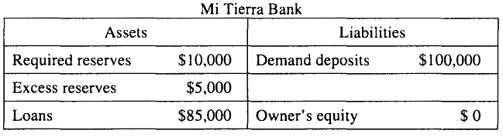
(a)What is the reserve requirement?
(b)Assume that Luis withdraws $5,000 in cash from his checking account at Mi Tierra Bank.
(i)By how much will Mi Tierra Bank's reserves change based on Luis' withdrawal?
(ii)What is the initial effect of the withdrawal on the M1 measure of money supply? Explain.
(iii)As a result of the withdrawal, what is the new value of excess reserves on the balance sheet of Mi Tierra Bank based on the reserve requirement from part (a) ?
(c)Assume that the next day John withdraws from Mi Tierra Bank an amount that exceeds the bank's excess reserves. Assuming that no loans are called in, how can Mi Tierra Bank cover its required reserves?

2011

1.Assume that the United States economy is currently in a recession in a short-run equilibrium.
(d)Assume that the Federal Reserve uses monetary policy to stimulate the economy.
(i)What open-market policy should the Federal Reserve implement?
(ii)Using a correctly labeled graph of the money market, show how the policy in part (d)(i) affects nominal interest rates.
(iii)What will be the impact of the policy on the price level? Explain.

3.Sewell Bank has the following simplified balance sheet:
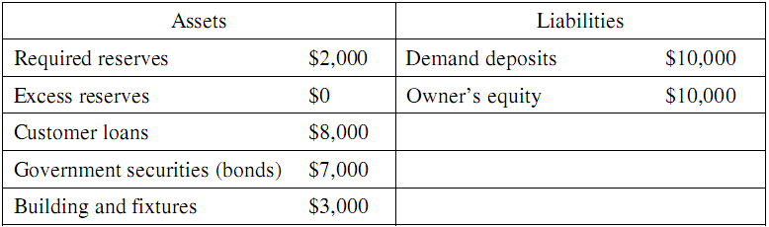
(a)Based on Sewell Bank’s balance sheet, calculate the required reserve ratio.
(b)Suppose that the Federal Reserve purchases $5,000 worth of bonds from Sewell Bank. What will be the change in the dollar value of each of the following immediately after the purchase?
(i)Excess reserves
(ii)Demand deposit
(c)Calculate the maximum amount that the money supply can change as a result of the $5,000 purchase of bonds by the Federal Reserve.
(d)When the Federal Reserve purchases bonds, what will happen to the price of bonds in the open market? Explain.
(e)Suppose that instead of the purchase of bonds by the Federal Reserve, an individual deposits $5,000 in cash into her checking (demand deposit) account. What is the immediate effect of the cash deposit on the M1 measure of the money supply?

2010 A

2.A drop in credit card fees causes people to use credit cards more often for transactions and demand less money.
(a)Using a correctly labeled graph of the money market, show how the nominal interest rate will be affected.
(b)Given the interest rate change in part (a), what will happen to bond prices in the short run?
(c)Given the interest rate change in part (a), what will happen to the price level in the short run? Explain.
(d)Identify an open-market operation the Federal Reserve could use to keep the nominal interest rate constant at the level that existed before the drop in credit card fees. Explain.

2010 B

2.The central bank of the country of Sewell sells bonds on the open market.
(a)Assume that banks in Sewell have no excess reserves. What is the effect of the central bank's action on the amount of customer loans that banks in Sewell can make?
(b)Using a correctly labeled graph of the money market, show the effect of the central bank's action on the nominal interest rate in Sewell.
(c)What is the effect of the central bank's action on each of the following in Sewell?
(i)Price level
(ii)Real interest rate. Explain.

2009 A

1.Assume that the United States economy is in long-run equilibrium with an expected inflation rate of 6 percent and an unemployment rate of 5 percent. The nominal interest rate is 8 percent.
(b)Calculate the real interest rate in the long-run equilibrium.
(c)Assume now that the Federal Reserve decides to target an inflation rate of 3 percent. What open-market operation should the Federal Reserve undertake?
(d)Using a correctly labeled graph of the money market, show how the Federal Reserve's action you identified in part (c) will affect the nominal interest rate.
(e)How will the interest rate change you identified in part (d) affect aggregate demand in the short run? Explain.

3.Assume that the reserve requirement is 20 percent and banks hold no excess reserves.
(a)Assume that Kim deposits $100 of cash from her pocket into her checking account. Calculate each of the following.
(i)The maximum dollar amount the commercial bank can initially lend
(ii)The maximum total change in demand deposits in the banking system
(iii)The maximum change in the money supply
(b)Assume that the Federal Reserve buys $5 million in government bonds on the open market. As a result of the open market purchase, calculate the maximum increase in the money supply in the banking system.
(c)Given the increase in the money supply in part (b), what happens to real wages in the short run? Explain.

2009 B

2.In Country Z, the required reserve ratio is 10 percent. Assume that the central bank sells $50 million in government securities on the open market.
(a)Calculate each of the following.
(i)The total change in reserves in the banking system
(ii)The maximum possible change in the money supply
(b)Using a correctly labeled graph of the money market, show the impact of the central bank's bond sale on the nominal interest rate.
(c)What is the impact of the central bank's bond sale on the equilibrium price level in the short run?
(d)As a result of the price level change in part (c), are people with fixed incomes better off, worse off, or unaffected? Explain.

