The following table shows the quantity demanded and quantity supplied for bushels of wheat at various prices. Which of the following combinations is the equilibrium price and quantity for wheat?
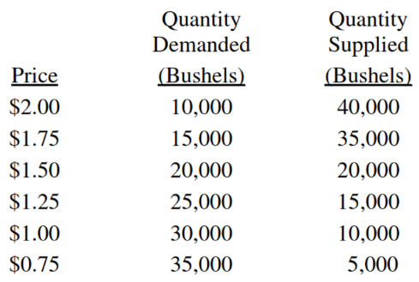
 | Price | Bushels of Wheat
(A) | $2.00 | 10,000
(B) | $1.75 | 15,000
(C) | $1.50 | 20,000
(D) | $1.25 | 30,000
(E) | $0.75 | 5,000

A simultaneous increase in both the demand for and the supply of a good in a market will lead to which of the following changes in the equilibrium price and quantity of the good?
(A) Price = Increase ; Quantity = Increase
(B) Price = Indeterminate ; Quantity = Decrease
(C) Price = Indeterminate ; Quantity = Increase
(D) Price = Increase ; Quantity = Indeterminate
(E) Price = Decrease ; Quantity = Increase

If the production technology of a good improves and at the same time the number of consumers willing and able to buy the good in the market increases, which of the following will definitely occur?
(A)Equilibrium price will increase.
(B)Equilibrium price will decrease.
(C)Equilibrium quantity will increase.
(D)Equilibrium quantity will decrease.
(E)Equilibrium quantity will remain the same.

If one-fourth of a nation's wheat crop is destroyed by a flood in a given season, then the price of wheat and the quantity sold will change in the short run in which of the following ways?
(A)Price = Decrease ; Quantity Sold = No Change
(B)Price = Decrease ; Quantity Sold = Increase
(C)Price = Increase ; Quantity Sold = Decrease
(D)Price = Increase ; Quantity Sold = Increase
(E)Price = No Change ; Quantity Sold = Increase

Which of the following changes in the supply of and the demand for a good will definitely result in a decrease in both the equilibrium price and quantity of the good?
(A)Supply = Increase ; Demand = Increase
(B)Supply = Increase ; Demand = No Change
(C)Supply = No Change ; Demand = Decrease
(D)Supply = Decrease ; Demand = Increase
(E)Supply = Decrease ; Demand = Decrease

If labor costs rise in the automobile industry, which of the following will happen to car prices and the quantity of cars sold?
(A)Price = Decrease ; Quantity Sold = Decrease
(B)Price = Decrease ; Quantity Sold = Increase
(C)Price = Increase ; Quantity Sold = Decrease
(D)Price = Increase ; Quantity Sold = Increase
(E)Price = Increase ; Quantity Sold = Not Change

If an effective price floor is removed from a market for a good, then the price and quantity of the good sold will change in which of the following ways?
(A)Price = Increase ; Quantity = Increase
(B)Price = Increase ; Quantity = Decrease
(C)Price = Decrease ; Quantity = Increase
(D)Price = Decrease ; Quantity = Decrease
(E)Price = No Change ; Quantity = Increase

Which of the following will occur in a competitive market when the price of a good is less than the equilibrium price?
(A)Price will decrease to eliminate the surplus and restore equilibrium.
(B)Price will decrease to eliminate the shortage and restore equilibrium.
(C)Price will increase to eliminate the surplus and restore equilibrium.
(D)Price will increase to eliminate the shortage and restore equilibrium.
(E)Price will remain constant, because supply will increase to eliminate shortage.

Assume that for consumers, pears and apples are substitutes. It is announced that pesticides used on most apples may be dangerous to consumers health. As a result of this announcement, which of the following market changes is most likely to occur in the short run for the pear market?
(A)
(B)
(C)
(D)
(E)

