2015

2.Country X and Country Y are trading partners, and both produce furnaces and solar panels. The countries can produce the following amounts using equal amounts of resources.

Country X: 6 furnaces or 8 solar panels
Country Y: 6 furnaces or 12 solar panels

(a)Which country has an absolute advantage in producing solar panels?
(b)Calculate the opportunity cost of a furnace in Country Y.
(c)Which country has the comparative advantage in producing furnaces? Explain.
(d)If the terms of trade were that 2 furnaces are exchanged for 1 solar panel, should Country X produce solar panels domestically or import solar panels from Country Y?

2013

2. Assume that the country of Fischerland produces only consumer goods and capital goods.

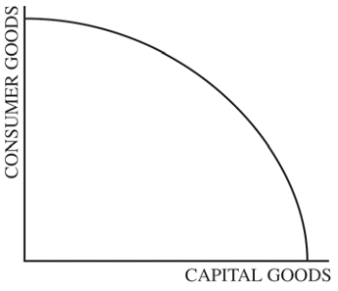

(a)The graph above shows the production possibilities curve for Fischerland. The production of which of the following exhibits increasing opportunity costs: consumer goods only, capital goods only, both goods, or neither good?
(b)Redraw the graph given above. Show a point that represents fully employed and efficiently used resources on the redrawn graph and label it A.
(c)Assume there is a recession in Fischerland. On your graph in part (b), label as C a point representing the recession.
(d)Identify a fiscal policy action that the Fischerland government can take to address the recession.
(e)Assume instead that no discretionary policy actions are taken. Will short-run aggregate supply increase, decrease, or remain the same in the long run? Explain.

2010 B

1.A country's economy is in a short-run equilibrium with an output level less than the full-employment output level. Assume an upward-sloping aggregate supply curve.
(e)Assume that the economy produces only two goods: military goods and civilian goods. Using a correctly labeled production possibilities curve, show the effect of the increase in military expenditures from part (b), labeling the initial point as C and the new point as D.

2008

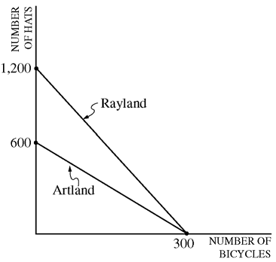

3.The diagram above shows the production possibilities curves for two countries: Artland and Rayland. Using equal amounts of resources, Artland can produce 600 hats or 300 bicycles, whereas Rayland can produce 1,200 hats or 300 bicycles.
(a)Calculate the opportunity cost of a bicycle in Artland.
(b)If the two countries specialize and trade, which country will import bicycles? Explain.
(c)If the terms of trade are 5 hats for 1 bicycle, would trade be advantageous for each of the following?
(i)Artland
(ii)Rayland
(d)If productivity in Artland triples, which country has the comparative advantage in the production of hats?

2004 B

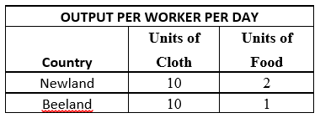

3.The table above gives the production alternatives of two nations that are producing cloth and food, using equal amounts of resources.
(a)(i) Calculate the opportunity cost of producing a unit of cloth in Newland.
(ii) Calculate the opportunity cost of producing a unit of food in Beeland.
(b)(i)Which nation has the comparative advantage in cloth production?
(ii) Which nation has the comparative advantage in food production?
(c)Now assume that the productivity of Beeland's workers triples for each good.
(i)Which country has a comparative advantage in food production?
(ii)Explain how you determined your answer.

2003

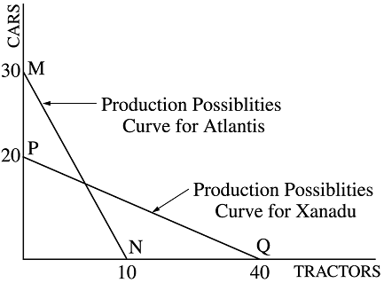

3.Assume that two countries, Atlantis and Xanadu, have equal amounts of resources. Atlantis can produce 30 cars or 10 tractors or any combination, as shown by the line MN in the figure above. Xanadu can produce 20 cars or 40 tractors or any combination, as shown by the line PQ in the figure above.
(a)Which country has an absolute advantage in the production of tractors? Explain how you got your answer.
(b)Which country has a comparative advantage in the production of cars? Using the concept of opportunity cost, explain how you determined your answer.
(c)If the two countries specialize and trade with each other, which country will import cars? Explain why.
(d)If the terms of trade are such that one car can be exchanged for one tractor, explain how Atlantis will benefit from such trade.

